# Wintergreen Chipping Area April 2018

# “I’m dreaming of a white summer??”

**Course Conditions Update**

We have been hard at work with a variety of continued plans, new initiatives, and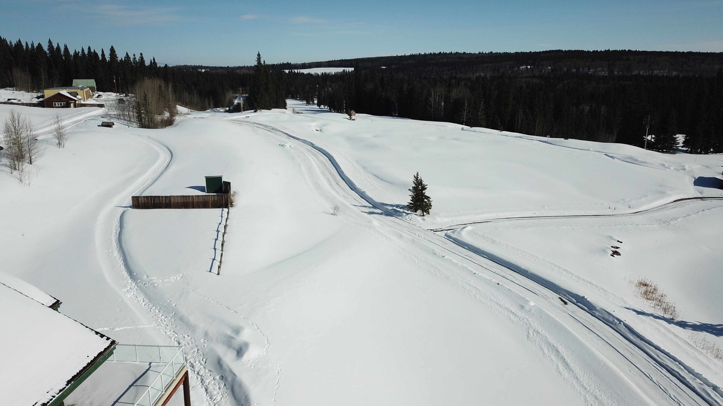 further developments to the experience and course we call home.



## UPCOMING EVENTS

**SAT MAY 26 OPENING SCRAMBLE**  **SIGNUP AT PROSHOP**

**THURS MAY 24 MEN’S NIGHT SIGNUP IN PROSHOP**

**TUES MAY 22 LADIES NIGHT CONTACT RHIANNON EVISON**

**DEADLINE MAY 20 MEN’S MATCHPLAY SIGNUP ONLINE**

Ac dolor ac quam adipiscing amet bibendum nullam.

## Duis Montes, Tellus Lobortis

In sodales libero suspendisse mauris quam etiam erat.

## Duis Montes Tellus Lobortis

Varius natoque ac turpis est leo primis elementum est.



### Mission

To represent all members of Wintergreen, work with RCR to promote the club and enjoyment of the game.



### VISION

Continued improvement of WG golf course. Increasing value and sustainability



### VALUES

Uphold and promote the traditions and values of the game. Honesty, Integrity, Sportsmanship and Respect



SPRING NEWSLETTER April 15, 2018

COURSE NEWSLETTER

WINTERGREEN GOLF & COUNTRY CLUB

**We all have a burning question................. will we golf this year and when is the course going to open?!?!**

We hear you, we understand, and as a golf community and lovers of the game we feel your pain as well!!!!

This year is clearly a trademark difference in the Calgary/area golf arena than other years. So then without further delay here's the update on the course:

**1) Current Work -** The Greens Committee, Superintendent (Chris Bach), and our General Manager (Alf Beaudry) have put in an incredible amount of work to do as much as they possibly can to ensure there are no delays from a groundskeeping aspect with respect to opening. This work will continue as always.

**2) Course & Greens Conditions -** were/have/are continuing to be monitored by the experts we have. Tasks of snow blowing critical areas, using various other equipment to clear, and continued monitoring are constant activities our course continues to complete and be involved in.

#### SENIOR MENT’S INTERCLUB

Kit Roberts is again leading the charge for the Senior Men’s Interclub. The schedule has been finalized and will be posted to the website shortly. Please contact Kit if you wish to partake in this event.

Kit Roberts - **403-404-1924 or** [krobertspcr@shaw.ca](mailto:krobertspcr@shaw.ca)(email preferred)

#### BUSINESS LADIES INTERCLUB

Pam Shewchuk & Rhiannon Evison continue to lead this event and are currently at work with activities. Schedules are being finalized and will be sent to those involved shortly. Please contact Pam or Rhiannon directly if you are interested in joining.

**Pam Shewchuk - [pam.shewchuk@gmail.com](mailto:pam.shewchuk@gmail.com) or Rhiannon Evison revison@gmail.com**

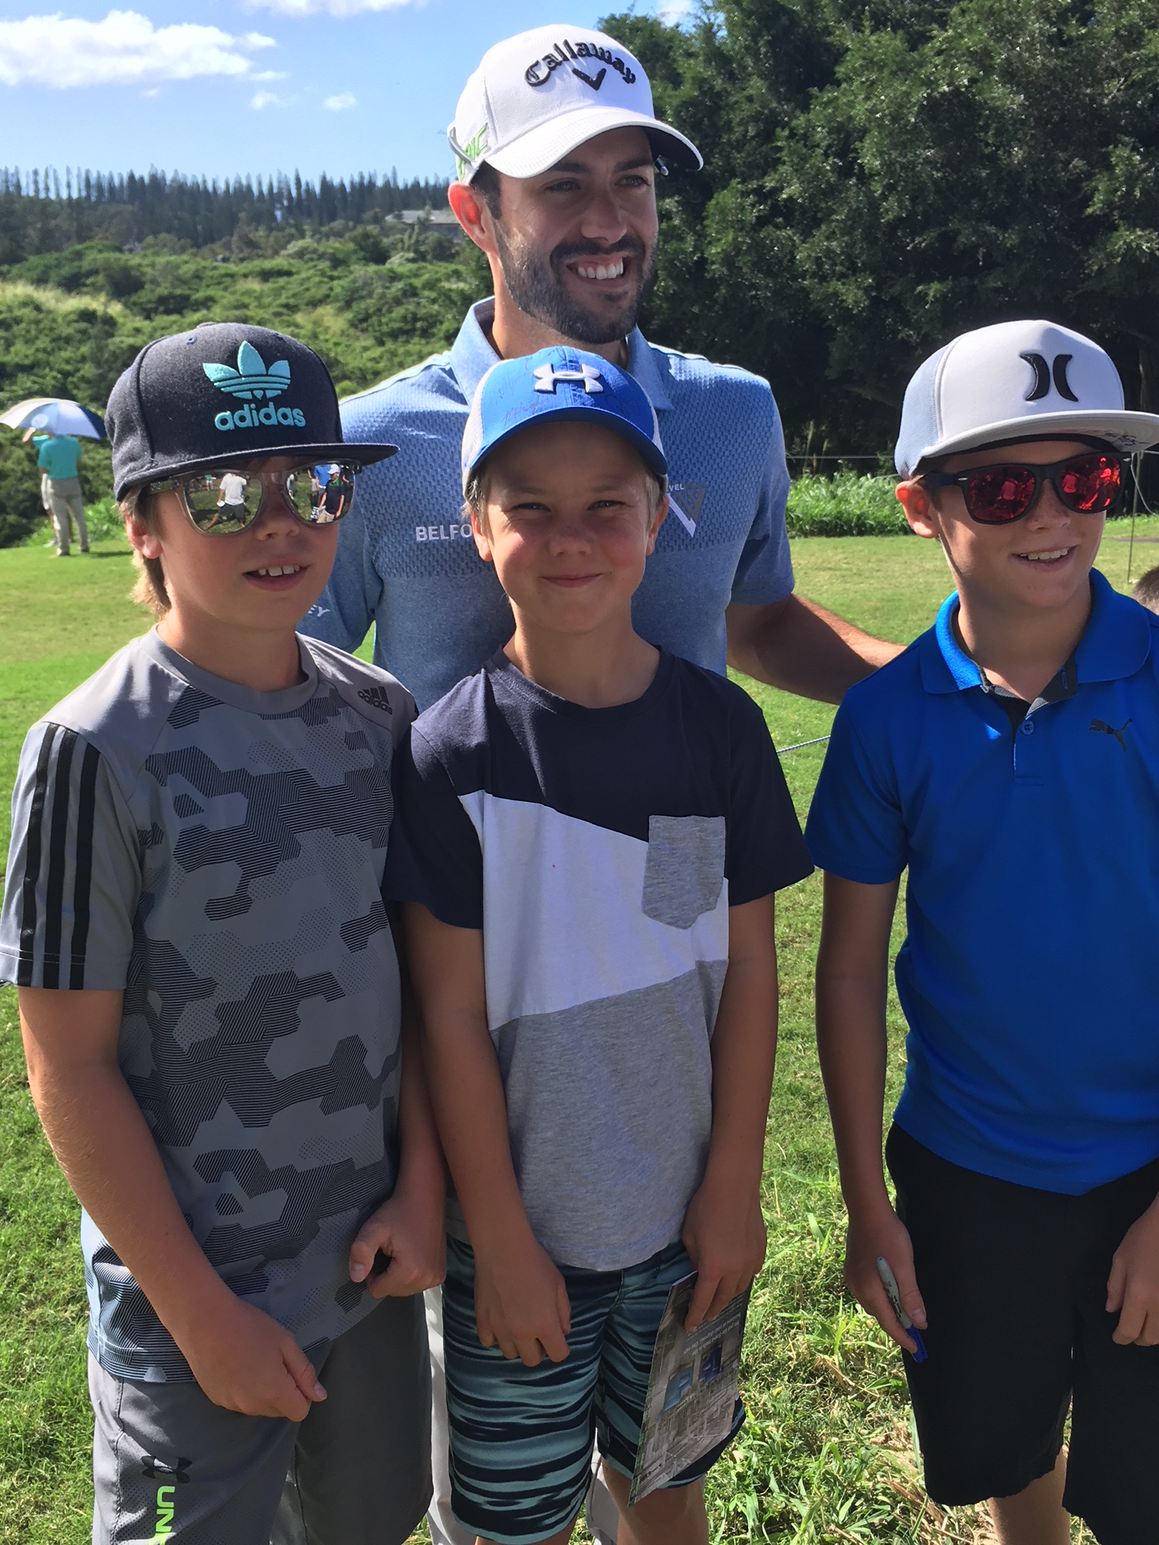

**DEADLINE MAY 20 LADIES MATCHPLAY CONTACT PROSHOP OR RHIANNON**

**SAT MAY 26 OPENING SCRAMBLE**  **SIGNUP AT PROSHOP**

**DEADLINE MAY 20 CAPTAINS CUP SIGNUP ONLINE**

**THURS MAY 24 MEN’S NIGHT SIGNUP IN PROSHOP**

**TUES MAY 22 LADIES NIGHT CONTACT RHIANNON EVISON**

**MAY 21, 2018 MEN’S MATCHPLAY SIGNUP ONLINE DEADLINE MAY 20**

Ac dolor ac quam adipiscing amet bibendum nullam.

## Duis Montes, Tellus Lobortis

In sodales libero suspendisse mauris quam etiam erat.

## Duis Montes Tellus Lobortis

Varius natoque ac turpis est leo primis elementum est.



**3) Opening Date - The current opening date is set for May 4.**

We are currently keeping this date as we don’t have reason right now to be changing this. The current wether forecast after tomorrow is set for +10 daily until then. **This being said the course will be re-evaluated April 23 (the week or NOT the day off).** Further email correspondence will be sent out after that date on the current status.

# EVENTS UPCOMING

The following is a list of activities and items that we are working on as your board of directors.

#### BUSINESS MENS INTERCLUB *** NEW EVENT ***

What what?!? Is this a mistake?? No it’s not. We currently have one course agreed to an interclub event with our course. We are currently working on more and a schedule. Event will commence mid/end May.

The following qualifiers must be met to participate

1. Participants must be under 55 years old and a good standing member of the club
2. Handicaps must be no higher than 10

We’re working out final details but we will communicate when we have more information.

**For now we ask that any/all men who fit these perimeters and wish to join please contact Josh or Les to sign up.** We need all participants as this has taken years to accomplish and we really want to make this a long standing event.

**Les Jedlicska - [lesjed@gmail.com](mailto:lesjed@gmail.com) or Josh Friesen - [joshuafriesen@shaw.ca](mailto:joshuafriesen@shaw.ca)**

#### LADIES MATCHPLAY

Ladies match play will again take place this year. Please contact Rhiannon Evison to coordinate this and advise if you are interested. Tentative signup deadline is May 20, 2018.

**Rhiannon Evison - revison@gmail.com**

#### MENS MATCHPLAY

We are again running this event for the 2018 season and is open to all members. Please signup online if you are interested. **The deadline for entry is May 20, 2018.** There will be two brackets and a double knockout system. Please note that this event will start with the registrants that are signed up deadline. We cannot accept late applicants so please sign up ASAP. Please also note that if the match is not completed by the deadline a coin flip will determine the winners. We intend to keep a tight accurate schedule this year to respect everyones time and efforts.

#### LADIES LEAGUE

Ladies league will also be returning for this upcoming year. Building on the successes and amazing event of last year there is current work to bring an even better experience to all. **Please contact your Ladies League Rep by May 20 to ensure registration**. Further information will be provided directly to the participants involved. Big shout out to all the sponsors as we couldn’t do this without you.

**Ladies League Rep - Rhiannon Evison - revison@gmail.com**

#### MENS LEAGUE

Mens league is also returning this year and will build on the great successes and formats of last year. Mr. Ric Kalef will be again running this event so please **contact the pro shop and register with payment.** Big shout out to the sponsors as we couldn’t do this without you.

### Mission

To represent all members of Wintergreen, work with RCR to promote the club and enjoyment of the game.



### VISION

Continued improvement of WG golf course. Increasing value and sustainability



### VALUES

Uphold and promote the traditions and values of the game. Honesty, Integrity, Sportsmanship and Respect



